Human Impacts on Coastal Ecosystems Lab
Overview

Time: 2 hours
Group Size: Up to 45 participants
Grade Levels: 9th Grade – Community College
Location: At Sea and Maddie James Seaside Learning Center (MJSLC)

PROGRAM DESCRIPTION

During our Human Impacts on Coastal Ecosystems Lab program students will investigate human effects on our local marine ecosystems. The lab includes a closer look at ocean imbalance with an emphasis on eutrophication in the ocean. Students will examine fouling plates to distinguish native, non-native and invasive species in the Dana Point harbor. Students will participate in a fish necropsy where they will study specific organs to determine if the fish could have been negatively impacted by its environment. Students will use scientific tools including water quality probes, quadrats, and microscopes to determine the magnitude of ecological disturbance on our coastline due to humans. The outcome of this program is directed towards empowering students to use their deeper knowledge of potential human impacts on the environment to design and advocate for improvements that impact coastal ecosystems.

INTRODUCTION

If the group is even a few minutes late it must be shortened. Stations should start no more than 15 minutes after the program start time, so shorten introduction as needed. If they are more than 15 minutes late in arriving, you will need to do this in 5 minutes and shorten stations as required to finish on time. You may even need to divide groups right away and do your own brief introduction with your group.
While one instructor is giving the intro, another instructor needs to group up the chaperones and give a chaperone talk.
Introduction:
Welcome to the Ocean Institute. Introduce self and instructors.
Today we will be focusing on Human Impacts on Coastal Ecosystems. The purpose of your field trip is to expose you to some of the processes scientists are currently using to monitor the health of our coast lines. You will be helping us with real on-going research projects that the Ocean Institute participates in collaboration with the Smithsonian Institute, Scripps, and the California Department of Health.
When you hear about “human impacts” on the environment, what do you think of? (Instructors may be able to gain an idea of students’ level of background knowledge from the answers they provide.) Today we will be investigating human impacts specifically on our coastal ecosystems. You will be participating in research being done along the West Coast. You’ll be rotating through three different research stations: a fish necropsy, water chemistry and jelly biology, and a study of invasive species in our harbor. At the end of our lab we’ll meet again as a group to discuss your findings and what that means for the future of our coasts.

Chaperone Talk:
Welcome to the Ocean Institute! Thank you for coming and giving your time so your students may have this experience.
Give a brief description of the program, timing, and rotations (ex. During this two hour living systems lab, students will move through four 30 minute stations with their group, each focusing on a different aspect of systems in the ocean and within and organism, and how organisms are adapted to their habitats).
Role of the chaperones:
- Our labs are inquiry-based learning stations meant to challenge and inspire the students, so we ask that you take a step back and allow them to fully engage in all of the stations.
- Please stay with the group you begin with and help the students focus on their work. Please assist with any behavior management issues.
- Your instructor may ask you to supervise the students in the event they need to step away or prepare lab materials, so please be prepared to step in.
- Please help the instructor by taking any students to the bathroom.
- Pictures of students should be candid so as not to distract from activities.
Breaking into Groups:
The instructor that talked to the teacher should give the student count and any information on groups to the instructor doing the introduction. If they have grouped in advance, the teacher will want to use them. If they have not, it is best if the teacher will just let you count off students, so no time is wasted. Do not do a 1- 2- 3 count, just quickly count off the number of students you need without looking like you are picking individual students out. Try to take a mix of both girls and boys. Make sure to count the number of students you have when you get to the first station, make sure you have the right number.

THREE STATIONS

1. Fish Necropsy
Students will participate in the necropsy of Pacific mackerels. They will identify various parts of the internal and external anatomy and study these organs for signs of health. Using visual aids and microscopes, smaller student groups will ‘specialize’ in one of these internal structures, taking an in-depth look for signs of pollution or other human impacts. Fish will also be measured and compared to average expected sizes for that species. Students will then discuss any evidence of illness or poor function, possible causes, and the potential impacts a smaller or less healthy population of fish could have on world oceans.

2. Invasive Species and Biofouling (Plate Watch Project)
Students will examine a series of settling plates and collect data regarding the abundance of organisms, biodiversity, and percent coverage. Students will then analyze their data to determine the impact of invasive and non-native species in the Dana Point harbor. Students will use this ecosystem as a model to describe the effect of physical disturbances on biodiversity and the spread of non-native organisms.

3. Ocean Imbalance and Eutrophication
Students will explore the effects of eutrophication while conducting hands on water quality testing and analyzing results. Students will test and record the nutrient levels (nitrate and phosphate), dissolved oxygen, pH, and temperature from three different water samples. Water samples will include a control sample and two additional samples (Sample A and B) with increasing amounts of liquid fertilizer to model how humans are impacting our coastal ecosystem through increased agricultural runoff attributed to population growth. Using the passing time between the dock and At Sea, you may briefly stop by the tank farm to show the students our Moon Jelly tanks and discuss how conditions like warming water may spike a jelly bloom.

SCHEDULE/LOGISTICS

Perfect Timing Example: (35) Minutes per stations
9:30 – 9:40 Introduction and divide into groups
9:40 – 10:15 Station 1
10:15 – 10:50 Station 2
10:50 – 11:25 Station 3
11:25 – 11:30 Line up and out the door

- Program Set Up:
- If it is the first program of your day, arrive 45 minutes before program start time. Read challenge sheets for equipment and preparation needed for each station. Make sure to get the fish out first, they take time to thaw.
- Pull out a plate watch wet table from the CCSI lab (where we conduct dockside water quality) and begin filling it with sea water, either with its pump or by placing a metal bin on the table to fill if the pump is broken. Buckets with an attached rope can be used to throw into the water off the dock to fill up the metal bins – ALWAYS CHANGE AT LEAST HALF OF THE WATER AT THE BEGINNING OF YOUR STATION IF THE PUMP DOESN’T WORK.
- iPads and probes are kept near the science cubicle. Ask the coordinator or manager whether they will be used for water chemistry or whether we will be using our standard instruments.

- Bring Them In:
- Decide who will do the introduction during set up time; it is important to start the program on time.
- Staff should go to the front the Ocean Institute when set up is done (at least 10 minutes before program start time). If the science coordinator is not available for check-in, one instructor can talk to the teacher to get numbers, make sure they have checked in, discuss groups, etc. while the other instructors get the students ready to go in and bring up the rear to close the side gate.
- If there is time, you can have the students use the restroom before bringing them into the lab for an introduction. If the school is more than 15 minutes late, please talk to the teacher to see if they can wait to go to the bathroom until lab begins.
- If it is not raining have the students put any gear, backpacks, etc. in the buckets outside of the At Sea building before they come into the room. Make sure students sit on the floor, not blocking the doors to the tank farm or husbandry office.

- Give Introduction and Break into Groups

- Station rotation (35 minutes each): 1) Fish Necropsy 2) Ocean Imbalance 3) Invasive Species and Biofouling (Plate Watch)

- Conclusion/Ending Program:
- During your lessons today you learned that the ocean ecosystem is a dynamic and ever-changing environment. By looking at the whole system, scientists can form an idea about how our actions might affect it. Nutrient loading, habitat destruction or alterations, and invasive species can cause animals to seek new habitats, allow toxic organisms to thrive, or negatively affect an ecosystem and its inhabitants’ health. So, as you leave the Ocean Institute, please keep in mind all of the things you learned and be a good steward of our oceans and the Earth we all share.
- Finish on time, line them up at the door. Make sure they know their program is over and ask the teacher what is next for them. Direct them to where they need to go. Make sure they understand they are to leave the campus. No eating lunch in the firepit area. Groups can go out into the Native Plant Garden to eat lunch and will not be allowed back on campus until lunch is over. Instructors take a 30-minute break while students are off campus eating their lunch.

ROOM DIAGRAMS
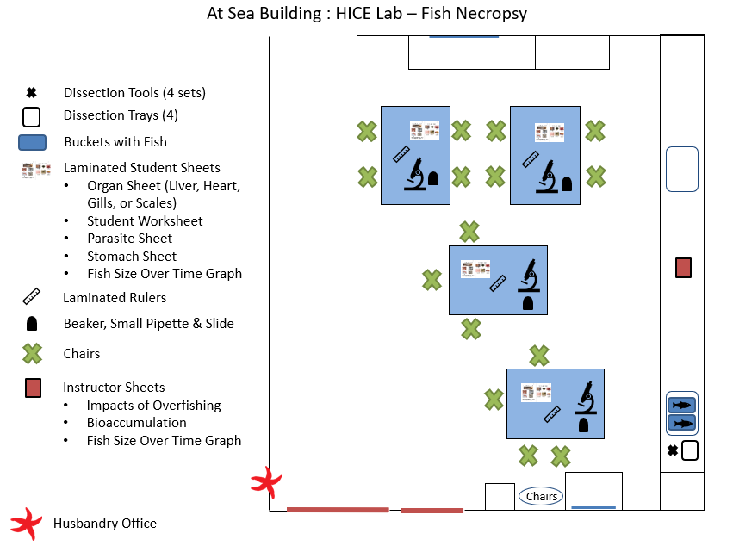

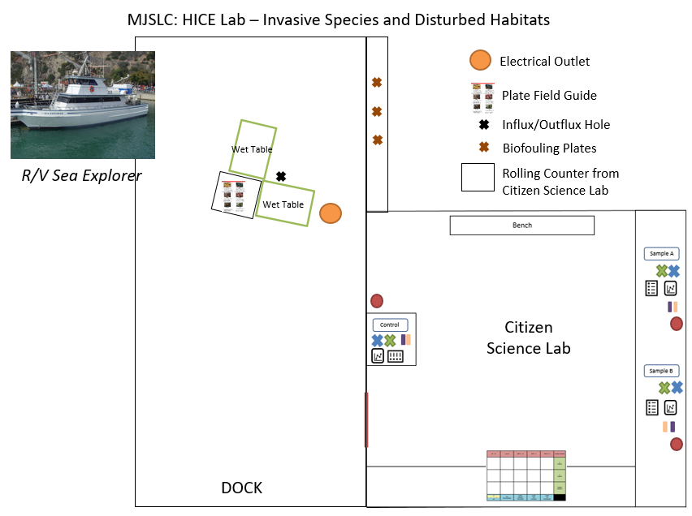

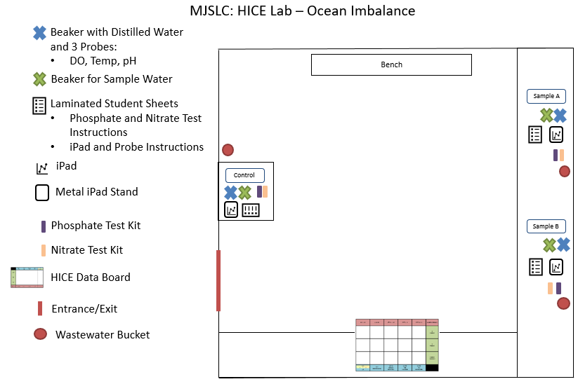

Stations (in order):
- Fish Necropsy
  - Defrost twelve fish per program (if this is a flip flop, you will need to pull out twenty-four fish). Grab fish from the Sahm kitchen freezer and place in a fish bucket with lukewarm water. Set up four lab tables throughout the room underneath a hanging outlet. Place three to four chairs around each table. Place a microscope, beaker with fresh water in it, pipette, petri dish, laminated ruler, and set of dissection sheets on each table. You may also do 3 tables for dissecting only and a 4th and final table for ALL microscopes, if there are few enough students to group them in 3 dissecting groups.
- Invasive Species and Disturbed Habitats (Plate Watch Project)
  - Pull one or two wet tables out of the Citizen Science Lab and place on the dock near the electrical outlet and the influx/outflux hole. Place the influx and outflux tubes into the harbor water through the hole on the dock. Follow the wet table procedure cards in the wat table base to begin flowing water into the tables. Place all of the field guides and mini transects/grids on a folding table kept in the CCSI and placed just outside for setup.
*See page 3, Program Setup (1b) if the table pumps do not work for alternative setup*
  - Do NOT take the plates off the side of the dock until the program begins. The first group to this station will remove the plates and place them in the wet tables. The plates can then stay in the wet tables for the duration of the lab program. Once the program is done, please clip the plates back in the harbor water.
- Ocean Imbalance
  - Check out all technology for this station next to the science cubicle. These items include: three iPads, three temperature probes, three pH probes. All other materials for this station are stored in the CCSI Lab. Ask the coordinator whether all items work and will be used or if we resort to using our standard temperature probes and hyrdrometers.
  - Set up water samples throughout the room (please reference the Ocean Imbalance Room Schematic). Place a beaker with distilled water in it, an empty beaker, a nitrate and phosphate test kit, a timer, a pipette and laminated student sheets with each water sample. Place the HICE data board on the counter in the front of the lab.
  - Make sure to grab wastewater buckets, an expo marker, an eraser, and a few rags from At Sea and bring them down to the Citizen Science Lab when setting up this station.

STANDARDS

NGSS EXCERPTS DIRECTLY RELATED TO:
For more in-depth descriptions of these standards, please view at https://www.nextgenscience.org/
HS-LS2-1 Use mathematical and/or computational representations to support explanations of factors that affect carrying capacity of ecosystems at different scales.
- [Clarification Statement: Emphasis is on quantitative analysis and comparison of the relationships among interdependent factors including boundaries, resources, climate, and competition. Examples of mathematical comparisons could include graphs, charts, histograms, and population changes gathered from simulations or historical data sets.]

HS-LS2-2 Use mathematical representations to support and revise explanations based on evidence about factors affecting biodiversity and populations in ecosystems of different scales.
- [Clarification Statement: Examples of mathematical representations include finding the average, determining trends, and using graphical comparisons of multiple sets of data.]
HS-LS2-5 Use a model to illustrate the role of photosynthesis and cellular respiration in the cycling of carbon among the biosphere, atmosphere, hydrosphere, and geosphere.
- [Clarification Statement: Examples of models could include simulations and mathematical models.]
HS-LS-2-6 Evaluate claims, evidence, and reasoning that the complex interactions in ecosystems maintain relatively consistent numbers and types of organisms in stable conditions but changing conditions may result in a new ecosystem.
- [Clarification Statement: Examples of changes in ecosystem conditions could include modest biological or physical changes, such as moderate hunting or a seasonal flood; and extreme changes, such as volcanic eruption or sea level rise.]
HS-LS2-7 Design, evaluate, and refine a solution for reducing the impacts of human activities on the environment and biodiversity.
- [Clarification Statement: Examples of human activities can include urbanization, building dams, and dissemination of invasive species.]
HS-LS4-5 Evaluate the evidence supporting claims that changes in environmental conditions may result in (1) increases in the number of individuals of some species, (2) the emergence of new species over time, and (3) the extinction of other species.
- [Clarification Statement: Emphasis is on determining cause and effect relationships for how changes to the environment such as deforestation, fishing, application of fertilizers, drought, flood, and the rate of change of the environment affect distribution or disappearance of traits in species.]
HS-LS4-6 Create or revise a simulation to test a solution to mitigate adverse impacts on human activity on biodiversity.
- [Clarification Statement: Emphasis is on testing solutions for a proposed problem related to threatened or endangered species, or to genetic variation of organisms for multiple species.]
HS-ESS3-4 Evaluate or refine a technological solution that reduces impacts of human activities on natural systems.
- [Clarification Statement: Examples of data on the impacts of human activities could include the quantities and types of pollutants released, changes to biomass and species diversity, or areal changes in land surface use (such as for urban development, agriculture and livestock, or surface mining). Examples for limiting future impacts could range from local efforts (such as reducing, reusing, and recycling resources) to large-scale geoengineering design solutions (such as altering global temperatures by making large changes to the atmosphere or ocean).]

